21.91: (a) As in 22.72: 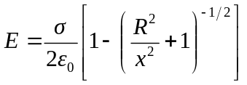
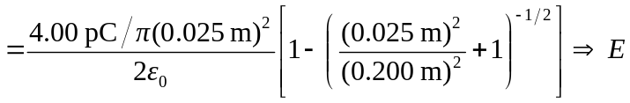
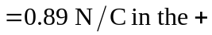x-direction.
b) 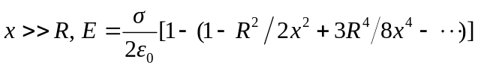
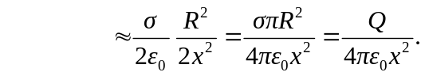
c) The electric field of (a) is less than that of the point charge (0.90 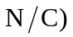since the correction term that was omitted was negative.
d) From above 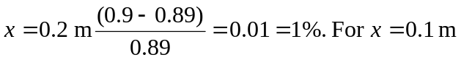
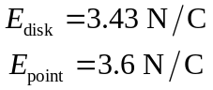
so 